Virginia States University
Department of Engineering and Computer Science
ENGR 102-01 – Introduction to Engineering (Fall 2020)

Date:
HW #: 1 (Chapters 5: Electrical Circuits)

On my honor, I have neither given nor received any unauthorized aid on this test, and I pledge that I am in compliance with the VSU Honor System.

Print Name Signature

Instructions: Show your work to get full credit. Partial credit will be given where appropriate.
- Find the current in amperes if 96 mC of charge pass through a wire in 8.4 s.
$Q=it$
I = $\frac{Q}{t}$ = $\frac{96 mC}{8.4s}$ = 11.43 mA

- Will a fuse rated at 1 A “blow” if 86 C pass through it in 1.2 min?
$Q=it$
I = $\frac{Q}{t}$ = $\frac{86C}{1.2*60s}$ = 1.2 A
Yes it will blow because the rated current of the fuse is lower than the current passing through.

- If 0.84 × 10 ⁺ ¹⁶ electrons pass through a wire in 60 ms, find the current.

$1 C=6.242 ×{10}^{18}\grave{e}$
$so 0.84 ×10^{16}e= \frac{0.84 ×10^{16}}{6.242 ×{10}^{18}}=1.3457×10^{-3}C=1.3457mC$
I = $\frac{Q}{t}$ = $\frac{1.3457mC}{60 ms}$ = 0.02243 A = 22.43mA

- If a voltmeter has an internal resistance of 50 kΩ, find the current through the meter when it reads 120 V.
$V=IR$
I = $\frac{V}{R}$= $\frac{120 V}{50×{10}^{3}}$ = $2.4×{10}^{-3}A=2.4mA$

- What power is delivered by a 12 V battery if the current drain is 40 A?

$P=IV$
P= 12*40 = 480 Watts

- A common resistance of carbon resistors is 68 Ω. How many 68-Ω resistors, connected in parallel, are needed to give a total resistance of 13.6 Ω?
When resistors are added in parallel connection, total resistance is given by expression:
- $\frac{1}{R_{T}}=\frac{1}{R_{1}}+\frac{1}{R_{2}}+\frac{1}{R_{3}}+…$ (resistors in parallel)
If n resistors have been added then $\frac{1}{R}=\frac{n}{r}$ where r = 68-Ω and R = 13.6 Ω
$\frac{1}{13.6}=\frac{n}{68}$ ,, n = $\frac{68}{13.6}$ = 5
= 5 resistors

- Find the total resistance for the resistor circuit shown below:

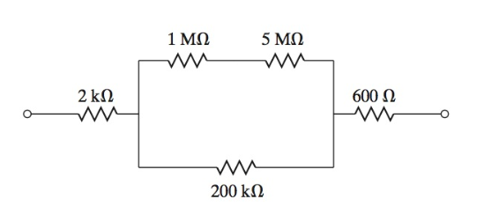
1MΩ+ 5MΩ = 6 MΩ since they are in series
6 MΩ is in parallel with 200kΩ hence = $\frac{6 MΩ*0.2 MΩ}{6+0.2}$ =$\frac{1.2}{6.2}$ =0.19355 MΩ = 193.55 kΩ
193.55 kΩ is in series with 2 kΩ and 0.6 kΩ = 193.55 kΩ + 2kΩ+ 0.6kΩ = 196.15 kΩ
Total resistance = 196.15 kΩ

- Four resistors are connected in parallel across a 200-mA independent current source as shown in the figure below. What is the voltage across the resistors and the current in each resistor?
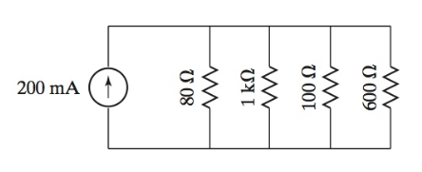
$\frac{1}{R_{T}}=\frac{1}{R_{1}}+\frac{1}{R_{2}}+\frac{1}{R_{3}}+…= \frac{1}{R_{T}}=\frac{1}{80}+\frac{1}{1000}+\frac{1}{100} +\frac{1}{600}= \frac{151}{6000}$
$Rt= \frac{6000}{151}=39.735Ω$
$V=IR=0.2A*39.735=7.95 V$
Voltage across the resistors = $7.95V$
Current through 80Ω = $\frac{7.95}{80}$ = 0.0994 A
Current through 1000Ω = $\frac{7.95}{1000}$ = 0.00795A
Current through 100Ω = $\frac{7.95}{100}$ = 0.0795A
Current through 600Ω = $\frac{7.95}{600}$ = 0.01325A
- For the DC circuit shown below, find the voltage across each resistor and the current in each resistor. Find the power dissipations in the 20Ω and 100Ω resistors.

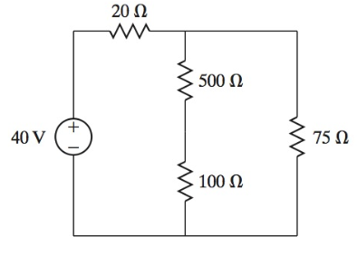

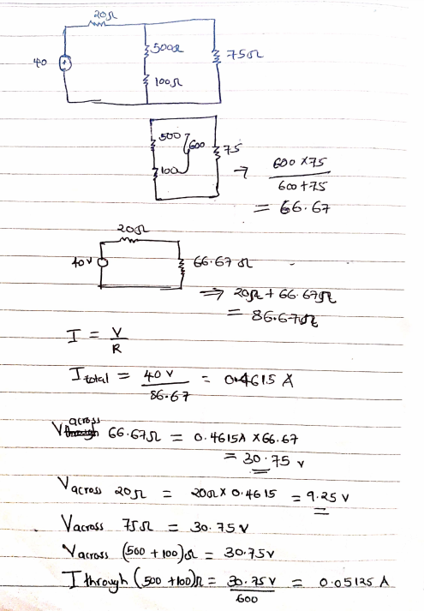

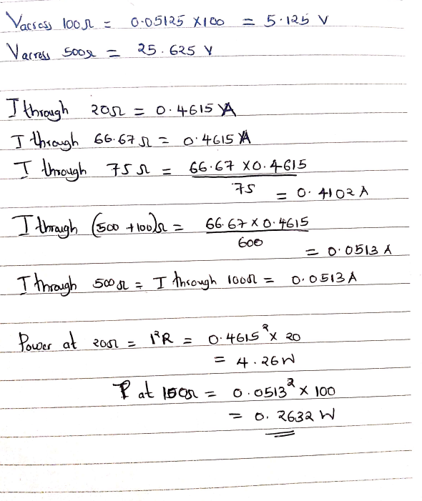

- For the DC circuit shown in the accompanying figure, find the voltage across each resistor and the current through each resistor. Use the general analysis procedure to present your answer.
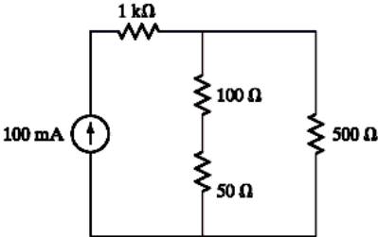

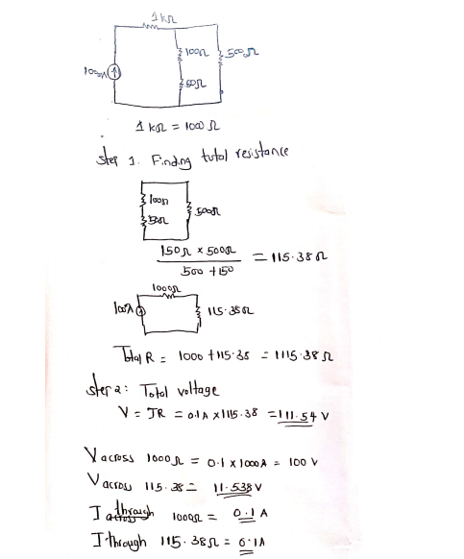

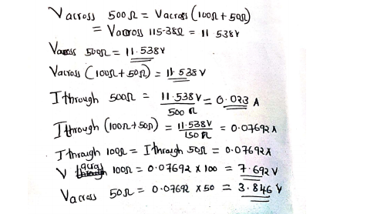

Useful Equations:
- $F=k\frac{q_{1}q_{2}}{r^{2}}$ $k=9.0×{10}^{9 }Nm^{2}/C^{2}$
- $Q=it$
- $1 C=6.242 ×{10}^{18}\grave{e}$
- $V=IR$
- $P=IV$
- $P=I^{2}R$
- $P=\frac{V^{2}}{R}$
- $\frac{1}{R_{T}}=\frac{1}{R_{1}}+\frac{1}{R_{2}}+\frac{1}{R_{3}}+…$ (resistors in parallel)
- $R_{T}=R_{1}+R_{2}+R_{3}+…$ (resistors in series)
- $\sum{I_{in}=0 at a node}$ (KCL)
- $\sum{V}= 0 around a loop.$ (KVL)

